

American International University-Bangladesh (AIUB)

**Department of Computer Science**

**Faculty of Science & Technology (FST)**

**Hair Salon Reservation System**

A Software Requirement Engineering Project Submitted By

|  |  |  |  |  |
| --- | --- | --- | --- | --- |
| **Semester: Spring_22_23** | | **Section: G** | **Group Number: 6** | |
| SN | Student Name | Student ID | Contribution (CO1+CO2) | Individual Marks |
| 5 | SHAZID - BIN - ZAMAN | 20-42127-1 |  |  |
| 7 | AMIT PODDER | 20-42273-1 |  |  |
| 15 | MIRZA MD. TAWHID | 20-42643-1 |  |  |
| 16 | TASNIM BINTA HOSSAIN SHAKAL | 20-42711-1 |  |  |

The project will be Evaluated for the following Course Outcomes

|  |  |  |
| --- | --- | --- |
| Evaluation Criteria | Total Marks (50) | |
|  | |
| Introduction, Format, Submission, Defense | [10 Marks] |  |
| System Overall Description & Functional Requirements | [10 Marks] |  |
| System Quality Attributes and Project Requirements | [10 Marks] |  |
| UML and E-R Diagram with Data Dictionary | [10 Marks] |  |
| UI/UX Prototyping | [10 Marks] |  |

**Software Requirements**

**Specification**

**for**

**Hair Salon Reservation System**

**Version 1.0**

**Prepared by**

**SHAZID - BIN - ZAMAN**

**AMIT PODDER**

**MIRZA MD. TAWHID**

**TASNIM BINTA HOSSAIN SHAKAL**

**Department of Computer Science**

**American International University-Bangladesh (AIUB)**

**30 April, 2023**

Table of Contents

Revision History 3

1. Introduction 4

1.1 Purpose 4

1.2 Document Conventions 4

1.3 Intended Audience and Reading Suggestions 4

1.4 References 4

2. Overall Description 5

2.1 Product Perspective 5

2.2 Product Functions 5

2.3 User Classes and Characteristics 6

2.4 Operating Environment 7

2.5 Design and Implementation Constraints 8

2.6 User Documentation 8

3. System Requirements 9

3.1 System Features 9

3.2 Non-Functional/Quality Requirements 12

3.3 Project Requirements 14

4. Design and Interface Requirements 15

4.1 UML Diagrams 15

4.2 Data Dictionary 18

4.3 UI/UX Design Specification 20

# Revision History

|  |  |  |  |
| --- | --- | --- | --- |
| **Name** | **Date** | **Reason for Changes** | **Version** |
| Hair Salon  Reservation  System | 30/04/2023 |  | Version 1.0 |

# Introduction

## Purpose

This SRS describes the functional and non-functional requirements for software release 1.0 of the Salon Reservation System. The project team members will use this document to implement and verify the correct functioning of the system. Unless otherwise noted, all requirements specified here are committed for release 1.0. The software allows customers to book appointments online, select their preferred stylist, and choose their desired service. The purpose of the software is to make the reservation process more convenient for customers and more efficient for the salon. By automating the booking process, the salon can reduce the time spent on scheduling appointments, minimize errors, and improve customer satisfaction.

## Document Conventions

We have used bold letters to emphasize the main topics of the document. The document follows Times New Roman font with size 18 for the main heading, size 14 for the subheading, and Times New Roman font with size 12 for the content. Italic will represent helpful notes and comments. Abbreviations and definitions of some practical terms used by us are given below.

|  |  |
| --- | --- |
| Term | Definition |
| SRS | Software Requirement Specification is a document that thoroughly describes all of the functions of a proposed system and the constraints under which it must operate. Example: This Document |
| GDPR | General Data Protection Regulation |
| PCI | Payment Card Industry |
| DSS | Data Security Standard |
| OWASP | The Open Web Application Security Project |
| ETA | Estimated Time of Arrival |
| UI | User Interface |
| UML | Unified Modeling Language |

## Intended Audience and Reading Suggestions

This document aims to provide information about a project and its methodology to various readers, including salon owners, clients, system designers, developers, and testers. The document contains an introduction section that outlines the document's purpose, the scope of the project, and intended audience. Additionally, it includes an overview of the product, which covers topics such as its perspective, functionality, and supported operating system characteristics, as well as any design and implementation constraints. The document then goes on to detail both the functional and non-functional requirements of the system.

## References

UK Gov. (2018), *The Data Protection Act,* https://www.gov.uk/data-protection.

Agostino, D. (2012). The effectiveness of social software for public engagement. *International Journal of Engineering Business Management*, 4, 2–4. doi:10.5772/54475.

Chai A., Wen C. C. (2017). SHEARS INC. Salon Management System. *International Journal on Informatics Visualization,* 1, 2-6.

# Overall Description

## Product Perspective

The hair salon reservation software is a new, self-contained product. The system should allow users to schedule appointments online, manage stylist and service information, process payments securely, send notifications and reminders, provide reporting and analytics, manage customer relationships, track inventory, and ensure data security with access control features. A user-friendly interface, comprehensive database, and reliable payment processing system are essential features. The software should also provide a dashboard for easy tracking of key performance metrics and allow for customization of notifications and customer information. Strong security measures, including encryption and access control, should be in place to protect sensitive information.

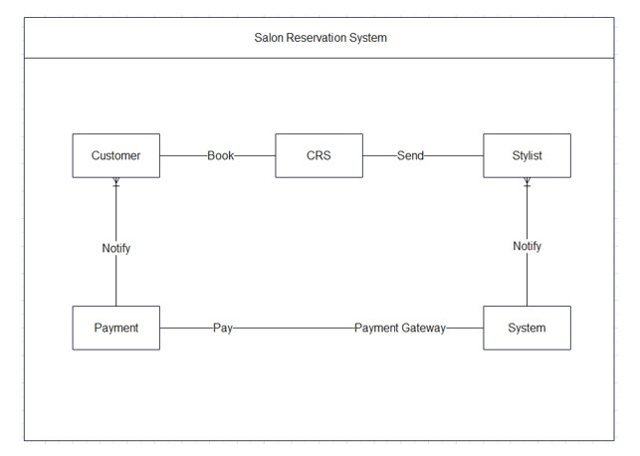

Fig 2.1: Context Diagram for the Hair Salon Reservation System for version 1.0.

## Product Functions

Here are the primary functions that a hair saloon reservation software should perform:

* User account management: Allow users to create accounts, log in, and manage their personal information, such as name, phone number, and email address.
* Appointment scheduling: Allow users to schedule appointments with hair stylists, specifying the desired service, date, time, and stylist preference.
* Stylist management: Allow salon managers to manage the hair stylists who work there, including their availability, skills, and schedules.
* Service management: Allow salon managers to manage the services offered by the salon, including their descriptions, prices, and availability.
* Payment processing: Allow users to pay for their appointments using various of payment methods, such as credit cards, debit cards, and online payment services.
* Notification and reminder: Automatically send notifications and reminders to users about upcoming appointments via email, text message, or push notification.
* Reporting and analytics: Provide salon managers with reports on key performance metrics, such as appointment volume, revenue, and customer satisfaction.
* Customer relationship management: Allow salon managers to maintain a customer information database, including their contact, appointment history, and preferences (Agostino, 2012).
* Inventory management: Allow salon managers to manage the inventory of products used in the salon, such as hair care products, styling tools, and accessories.
* Security and access control: Ensure the security of user data and restrict access to sensitive information to authorized personnel only.

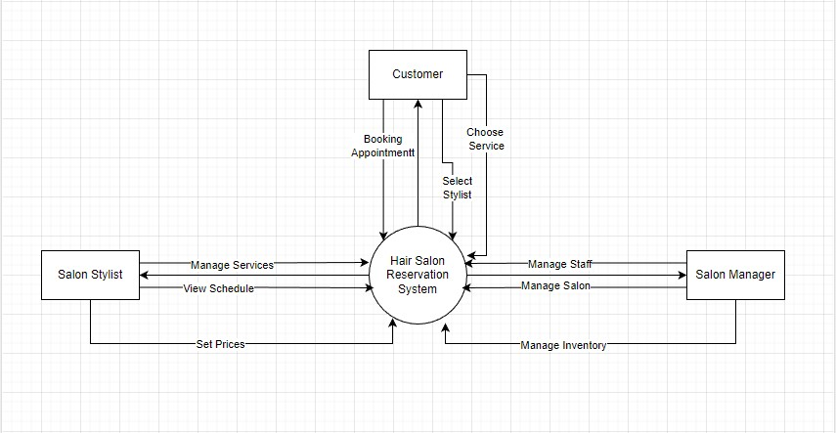

Fig 2.2: Data Flow Diagram for version 1.0.

## User Classes and Characteristics

The main people who have been identified as regular system users are as follows:

1. Customer.
2. Salon Managers.
3. Salon Stylist.

1. Customer:

* Customers use the hair salon reservation software to schedule appointments with their preferred stylist.
* They are expected to have basic computer skills and access to an internet-connected device.
* Customers may have different levels of technical expertise and familiarity with online booking systems, so the software should have a user-friendly interface that is easy to navigate.
* Customers may also have different needs and preferences, such as a specific stylist, service, or time slot, so the software should allow personalized booking options.
* The essential requirement for this user class is a seamless and efficient booking process allowing customers to schedule their appointments quickly and easily.

2. Salon Managers:

* Salon managers use the hair salon reservation software to manage their salon's schedule, stylists, services, inventory, and customer relationships.
* They are expected to have more advanced computer skills and may require training on the software to utilize its features thoroughly.
* Salon managers may have different levels of experience and require different access and security privileges within the software.
* The most important requirement for this user class is a comprehensive and customizable salon management system that allows them to manage their salon's operations and resources efficiently.

3. Salon Stylists:

* Stylists can create profiles within the software, including their contact information, work history, certifications, and availability.
* Stylists can view their schedules and appointments in real time and should be notified of any new or canceled appointments.
* Stylists can manage their services and set their prices for each service.

## Operating Environment

Hardware Platform:

* The software should be compatible with various hardware platforms, including desktop computers, laptops, tablets, and smartphones.
* The software should be optimized for the hardware platform it uses to ensure smooth and efficient performance.

Operating System and Versions:

* The software should be compatible with different operating systems, including Windows, MacOS, and Linux.
* The software should also be compatible with web browsers, including Google Chrome, Mozilla Firefox, and Apple Safari.

Software Components or Applications:

* The software should peacefully coexist with other software components or applications commonly used by hair salons, such as salon management software and payment processing systems.
* The software should be designed to integrate with existing salon management software systems, allowing salon managers to easily access and manage appointment information.
* The software should also be designed to integrate with payment processing systems, allowing customers to securely and conveniently make online payments.

## Design and Implementation Constraints

1. Regulatory Policies:
   * The software must comply with relevant data protection and privacy laws, such as GDPR (UK Gov, 2018).
   * The software must also comply with any other relevant regulations and industry standards, such as PCI DSS for payment processing.
2. Hardware Limitations:
   * The software must be able to handle large volumes of data without compromising performance, particularly during peak booking periods.
3. Specific Technologies and Tools:
   * The software must be developed using C# language or framework, and libraries that are best suited to the task.
   * The software may need to be designed to work with corporate standard Oracle database engine.
4. Security Considerations:
   * The software must be designed with strong security features, such as user authentication and data encryption, to protect against unauthorized access or data breaches.
   * The software must comply with relevant security standards, such as OWASP for web application security.

## User Documentation

1. User Manuals:

* The software will include a user manual that provides step-by-step instructions for using the system to book appointments, manage salon resources, and access other features.
* The manual will be available in electronic and print formats upon request.

2. Tutorials:

* The software will include interactive tutorials demonstrating how to use the system's features in a guided, hands-on manner.
* The tutorials will help new users get up to speed quickly and efficiently.

The hair salon reservation software will adhere to relevant documentation standards, such as ISO/IEC/IEEE 26514:2008 for software user documentation, to ensure that the user documentation is of high quality and meets the needs of its intended audience.

# System Requirements

## System Features

1. **Software Register**

**Functional Requirements (FRs)**

* 1. The software shall allow new users to register new accounts.
  2. The software shall allow users to log in with their social or email accounts.
  3. If the user wants to register, the system shall want email, name, phone, address, and date of birth.
  4. The system shall notify the user if the user does not fill up any section.
  5. If the user inputs an already registered email, the system shall notify the user to log in.

**Priority Level:** High

**Precondition:** No

**Cross-references:** NA

1. **Find Stylist**

**Functional Requirements (FRs)**

* 1. The software shall allow the users to show the available stylists.
  2. The software shall allow the users to know details about the stylist.

**Priority Level:** High

**Precondition:** The user has logged in

**Cross-references:** NA

1. **Services**

**Functional Requirements (FRs)**

* 1. The software shall allow the users to show possible services.
  2. The software shall allow the users to book possible services.

**Priority Level:** High

**Precondition:** The user has logged in (3.2).

**Cross-references:** 1.2

1. **Custom Service**

**Functional Requirements (FRs)**

* 1. The software shall allow the users to plan a custom service as the users want.
  2. If the user selects different services, they will automatically be added and sorted according to time and date.
  3. If any user wants to customize any packaged plan, they can do it.
  4. If users want extra facilities, they can mention them while scheduling the appointment. *[Optional function]*

**Priority Level:** High

**Precondition:** The user has logged in (4.2).

**Cross-references:** 1.2,2, 3.2, 5, 7

1. **Chat**

**Functional Requirements (FRs)**

* 1. The software shall allow the customers to communicate live with the manager or stylist by texting.
  2. The software shall allow users to get frequently asked questions instantly.

**Priority Level:** High

**Precondition:** The user has logged in

**Cross-references:** 1.2,8.1, 8.2

1. **Search**

**Functional Requirements (FRs)**

* 1. The software shall allow the users to search for services, stylists, and appointments.
  2. The software shall show the most relevant search result according to age.
  3. If the user wants to filter the search result according to the choice, the system shall provide a filtered search.

**Priority Level:** High

**Precondition:** NA

**Cross-references:** 2, 3.2, 5, 7

1. **Pre-Booking**

**Functional Requirements (FRs)**

* 1. The software shall allow the users to book any service at any time they want.
  2. If the user wants to reserve any particular stylist, the system shall book according to date and availability.
  3. If the user does not fill up any section, the system shall notify the user.
  4. If the user inputs an already registered email, the system shall notify the user to log in.

**Priority Level:** High

**Precondition:** The user has logged in

**Cross-references:** 1.2,2, 3.2, 5

1. **Recommend App**

**Functional Requirements (FRs)**

* 1. If the user is using the desktop version, the system shall recommend the mobile version of the software.
  2. If the user uses the mobile version, the system shall recommend the desktop version of the software.

**Priority Level:** Low

**Precondition:** The user is using this software on any device **Cross-references:** NA

1. **Profile**

**Functional Requirements (FRs)**

* 1. The software shall allow the users to show what information the user has added to their profile.
  2. If the user wants to edit any profile information, the system shall allow it to change.
  3. The software shall allow the users to show the information of their transactions or appointments they had made and visited.
  4. If the user inputs an already registered email, the system shall notify the user to log in.

**Priority Level:** High

**Precondition:** The user has logged in

**Cross-references:** 1.3

1. **Contact us**

**Functional Requirements (FRs)**

* 1. The software shall allow the users to know about all communication platforms to the salon.

**Priority Level:** Medium

**Precondition:** NA

**Cross-references:** NA

1. **Catalog**

**Functional Requirements (FRs)**

* 1. The software shall show the user new service information and pictures discovered by the salon stylists.
  2. The software shall also show users the new stylist information and services.
  3. If the users want to book, the system shall prompt them to log in.

**Priority Level:** High

**Precondition:** NA

**Cross-references:** NA

1. **Track Appointment**

**Functional Requirements (FRs)**

* 1. The software shall allow the users to track their reserved appointment.
  2. The software shall show the user the service, what has been done, and what is next.
  3. If the appointment is delayed, the software shall provide an ETA for the next appointment.

**Priority Level:** Medium

**Precondition:** The user has logged in

**Cross-references:** 8.1, 8.2

1. **Calendar**

**Functional Requirements (FRs)**

* 1. The software shall provide the users with a calendar to know about the availability of any service.
  2. If the user has booked any service or stylist, it shall be marked in the calendar.

**Priority Level:** Low

**Precondition:** NA

**Cross-references:** NA

1. **Feedback**

**Functional Requirements (FRs)**

* 1. The software shall provide a star rating system after every service.

**Priority Level:** Medium

**Precondition:** The user has logged in

**Cross-references:** NA

## Non-Functional/Quality Requirements

**QA1: Availability:**

The system shall be 99.7% available on weekends between 11.00 am to 10.00 pm local time and at least 96.8% on weekdays between 9.00 am and midnight local time.

**Priority Level:** High

**Precondition:** Must have maintainability attribute **Cross-references:** Q/A-6

**QA2: Performance:**

|  |  |
| --- | --- |
| QA2.1 | Every web page should be visible within 7 seconds after clicking on a 50kbps modern connection (Chai A. et al., 2017). |
| QA2.2 | Web page refresh shall load between 2-3 seconds. |
| QA2.3 | Updating data shall take between 5 seconds. |
| QA2.4 | Authorization of an online payment transaction shall not take more than 3 seconds. |

**Priority Level:** Medium

**Precondition:** NA

**Cross-references:** NA **QA3: Flexibility:**

Any coder with at least one year of experience supporting this product shall be able to make a new copy output available to the product, including code modifications and testing, with no more than one hour of labor.

**Priority Level:** High

**Precondition:** NA

**Cross-references:** NA

**QA4: Integrity:**

Only auditors shall have a view of customers’ transactions history and their personal information.

**Priority Level:** High

**Precondition:** NA

**Cross-references:** QA2

**QA5: Portability:**

This software shall be easily transferable from one hardware/environment to another-for example, Windows to Linux.

**Priority Level:** Medium

**Precondition:** Must have Flexibility attribute

**Cross-references:** QA3

**QA6: Robustness:**

If the system fails before the customer reserved an appointment, the system shall be able to recover all changes made in the database being edited up to two minutes prior to the failure the next time the same customer starts the program.

**Priority Level:** Medium

**Precondition:** Must have Performance attribute **Cross-references:** QA1, QA2

**QA 5- Interoperability:**

The system and user registration shall be able to import any valid structure from the profile information database.

**Priority Level:** Medium

**Precondition:** Must have Integrity attribute **Cross-references:** QA4

## Project Requirements

* **Time:** The complete software shall be built in 14 weeks
* **Budget:** Developers will need 1.38 lacs Taka to complete this project.
* **Human Resources:** A team consisting of six members.
* **Environment:** Initially, the system developer will build the project for Windows, Android & MacOS operating systems following the Agile model.
* **Equipment:** Developers need equipment of Computers with four desks & Markerboard.
* **Bandwidth:** Developers need high bandwidth connection support, around 40 to 50 Mbps.
* **Tools:** The system developer needs Selenium tools to perform risk tests of the software in week 6.

# Design and Interface Requirements

## UML Diagrams

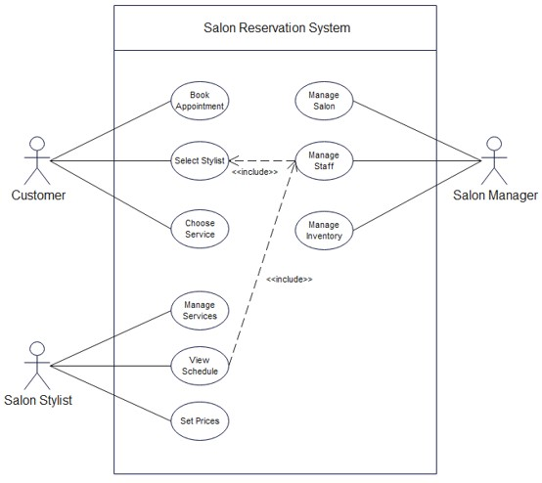

Fig 4.1.1: Use Case Diagram for version 1.0.

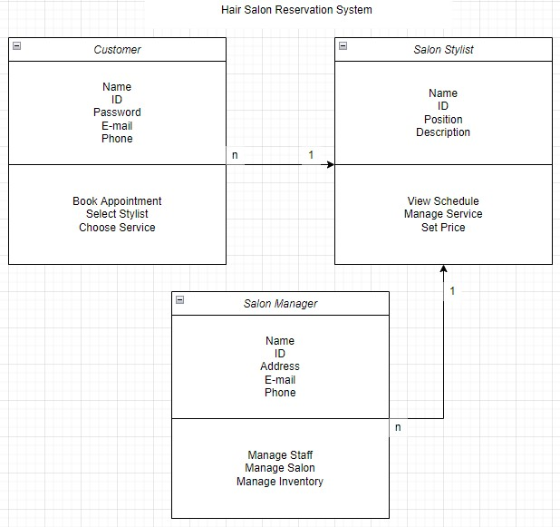

Fig 4.1.2: Class Diagram for version 1.0.

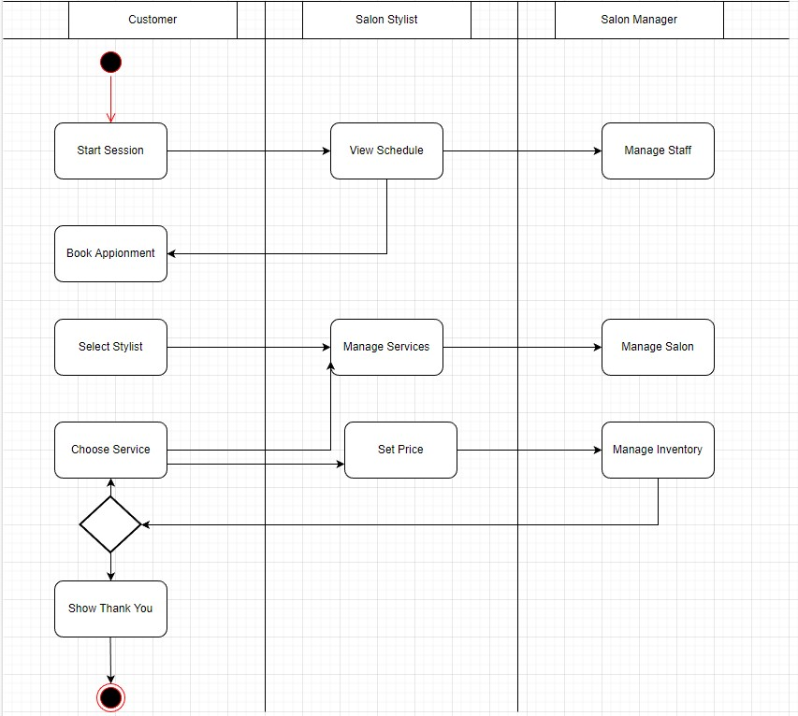

Fig 4.1.3: Activity Diagram for version 1.0.

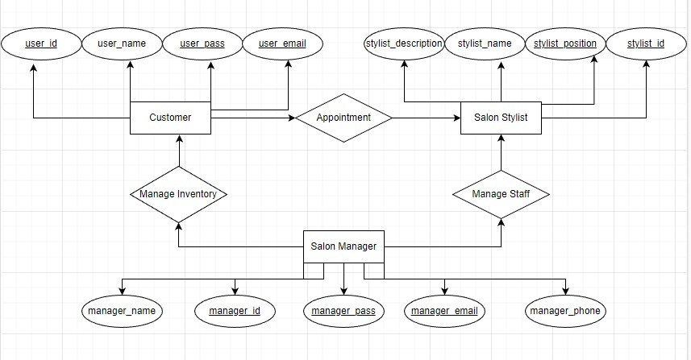

Fig 4.1.4: ER Diagram for version 1.0.

## Data Dictionary

|  |  |  |  |  |
| --- | --- | --- | --- | --- |
| Entity | Attribute | Type/Size | Validation | Key |
| Users | UserID | Unique identifier (7) | Not null, integer | Primary key |
| Users | Username | Text (20) | Not null, unique |  |
| Users | Password | Password (20) | Not null |  |
| Users | Email | Text (30) | Not null, unique, valid email format |  |
| Users | Phone | Text (20) | Not null, valid number format |  |
| Users | Role | Text (20) | Not null |  |
| Salons | SalonID | Unique identifier (7) | Not null, integer | Primary key |
| Salons | SalonName | Text (20) | Not null |  |
| Salons | Address | Text (50) | Not null |  |
| Salons | Phone | Text (20) | Not null, valid number format |  |
| Salons | Email | Text (30) | Not null, unique, valid email format |  |
| Services | ServiceID | Unique identifier (10) | Not null, integer | Primary key |
| Services | ServiceName | Text (20) | Not null |  |
| Services | Description | Text (100) | Not null |  |
| Services | Price | Decimal | Not null, greater than zero |  |
| Services | Duration | Time | Not null |  |
| Services | SalonID | Unique identifier | Not null, integer, foreign key to |  |
|  |  |  | Salons table |  |
| Stylists | StylistID | Unique identifier (7) | Not null, integer | Primary key |
| Stylists | StylistName | Text (20) | Not null |  |
| Stylists | Position | Text (20) | Not null |  |
| Stylists | Description | Text (100) | Not null |  |
| Stylists | SalonID | Unique identifier (7) | Not null, integer, foreign key to Salons table |  |
| Appointments | AppointmentID | Unique identifier (15) | Not null, integer | Primary key |
| Appointments | CustomerID | Unique identifier (7) | Not null, integer, foreign key to Users table |  |
| Appointments | SalonID | Unique identifier (7) | Not null, integer, foreign key to Salons table |  |
| Appointments | ServiceID | Unique identifier (10) | Not null, integer, foreign key to Services table |  |
| Appointments | StylistID | Unique identifier (7) | Not null, integer, foreign key to Stylists table |  |
| Appointments | AppointmentDate | DateTime | Not null |  |
| Appointments | Duration | Time | Not null |  |
| Appointments | Price | Decimal | Not null, greater than zero |  |
| Appointments | Status | Text (10) | Not null |  |

## UI/UX Design Specification

